**Creating a Web Page with Bootstrap**

**Materials & Tools:**

* Web Design Basics Book
* Online Source for Images and information
* Text Editor: Sublime Text

**Instructions:**

1. Create a webpage with three (3) Movie Reviews that apply Bootstrap 4.
2. The key elements of your web page should include the following:
   1. *HTML Structure.*  Follow the syntax for basic HTML structure which includes doctype, html, head (with title), and body.
   2. *Headings tags.* Create a proper heading for the page.
   3. *Paragraphs tags.* Insert information of the chosen movies.
   4. *CSS Span and DIV elements*. Organize web content.
   5. *CSS Texts, Colors, and Backgrounds.* Set and decorate texts with CSS properties.
   6. *Bootstrap Table.* Apply bootstrap classes for tables.
   7. *Bootstrap Images*. Style images with Bootstrap classes.
   8. *Link tags.* Include hyperlinks for your online sources.
3. Upload your site on GitHub.
4. Save your file with this filename format:

**Repository: Campus_ICT9Section_Q3Quiz1_LName_FName**

**HTML Filename: index.html**

1. Submit your REPO and MARKUP links through the OB Digital Platform and add the appropriate caption.

**REPO LINK:** [link to your repo here]

**LIVE PAGE LINK:** [link to your live page here]

**Sample Output:**

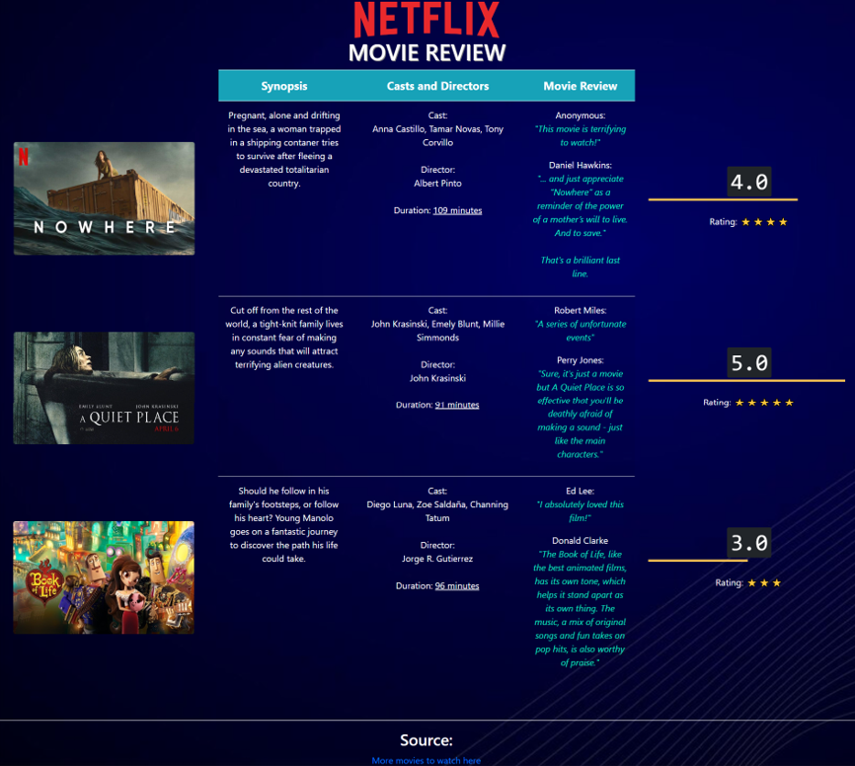

**RUBRICS:**

| **Criteria** | **E = 5** | **AS = 4** | **S = 3** | **NI = 2** | **P =1** |
| --- | --- | --- | --- | --- | --- |
| **Execution of Instructions** | Followed the instructions accurately.  Submitted the activity to the correct destination before the allotted time.  Saved with a correct filename. | Followed most of the instructions.  One instruction was skipped but it did not significantly affect the overall output.  Completed within the given time. | The output shows the basic framework.  Two instructions are skipped. | The output is missing important contents.  Three instructions are skipped. | The output has full of technical errors due to not following the instructions. |
| **Criteria** | **E = 15** | **AS = 12** | **S = 9** | **NI = 6** | **P =3** |
| **General Output** (Syntax, Content, Text Format, Layout, and Creativity) | The output clearly and effectively demonstrates an exceptional understanding of HTML tags and Bootstrap for styling colors, fonts, texts, and images.  Excellent HTML and Bootstrap structure and the output is working.  The format and layout show distinctions between major and minor contents.  Exercises creativity and the output goes beyond the minimum standard | The output demonstrates a clear understanding of the task and different parts work well with the rest of the elements.  Applies good format, layout, and creativity and the output meets the minimum standard. The output is working.  One to two elements are missing | The output demonstrates a fair understanding of the task, but some elements do not complement each other.  There are some attempts to follow format and layout and to show creativity and the output meets the standard. The output is working.  Three to four elements are missing | The output does not demonstrate an understanding of the task and most of the elements are not executed well.  Lacks attempts to show correct format and layout and to be creative. Some parts are not working.  Five to six elements are missing. | The overall output is incomplete, and it does not show understanding of the task.  The output is not working properly. |
| **TOTAL** | **20** | **16** | **12** | **8** | **4** |

